Woolala Iteration 0 Report

CSCE 606

Fall 2020

Hong-Jie Chen

Robert Hinck

Deokman Park

Hayden Roper

Thomas Rost

Chris Springstead

Team Roles

* Scrum Master: Deokman Paul Park
* Product Owner: Hayden Roper

Customer meeting date/time/place

* First meeting was September 27th, 2020 at 7PM CST.
* Meetings will occur with the customer after each sprint, but additional meetings may be scheduled during the sprint as needed.

Summary

The primary stakeholder, Tito (C.E.O. of FashioNXT), wants an app for everyday users to interact with fashion in a different way than the current medium of online articles and magazines. The fashion industry has been slow to adapt to the technologies of today. The customer envisions a mobile app highly tailored to promoting/expressing beautiful fashion. The mobile app will allow more engagement from the other stakeholder, social media users both in high fashion and not involved with fashion, by allowing users to upload their own pictures of “aesthetically pleasing content”. Other uses can rate the postings from 1 - 5 stars. The original poster will be able to get quantitative feedback from the app and learn the trends of everyday users.

The project was previously developed by a group in 2017/2018. We had a member from the previous team join the call. He informed us that the project will need to be scrapped and started from the beginning. He will assist us in creating the database schemas needed for the functions, but the other pieces are non-applicable for our uses.

User Stories

* Feature: Login through Facebook
  + As a user
  + I want to log in through facebook
  + So that I can access the app under my profile
* Feature: Login through Google
  + As a user
  + I want to log in through google
  + So that I can access the app under my profile
* Feature: Share a post to Facebook
  + As a user
  + I want to share a post to facebook
  + So that I can share the post that I’m interested in with my friends
* Feature: Feed
  + As a user
  + I want to see a feed
  + So that look at what my friends are up to
* Feature: Rating
  + As a user
  + I want to be able to rate the posting
  + So that I can know what I think about the posting
* Feature: Friend Request
  + As a user
  + I want to be able to send a friend request
  + So that I can friend other people on the platform
* Feature: Upload a posting
  + As a user
  + I want to be upload a new posting
  + So that I can share what I’m wearing
* Feature: Add Captions to postings
  + As a user
  + I want to be able to add a caption
  + So that I can add wording to describe the posting
* Feature: Share a post to Twitter
  + As a user
  + I want to be able to share the posting toTwitter
  + So that I can share what I’m looking at
* Feature: Create a new Profile
  + As a new user
  + I want to be able to create a new profile
  + So that I can start using the app
* Feature: Search for User Profiles
  + As a user
  + I want to be able to search and view profiles
  + So that I can find others in the app
* Feature: Camera
  + As a user
  + I want to be able to take a picture with the camera in the app
  + So that I can upload a post without closing the app

User Interface

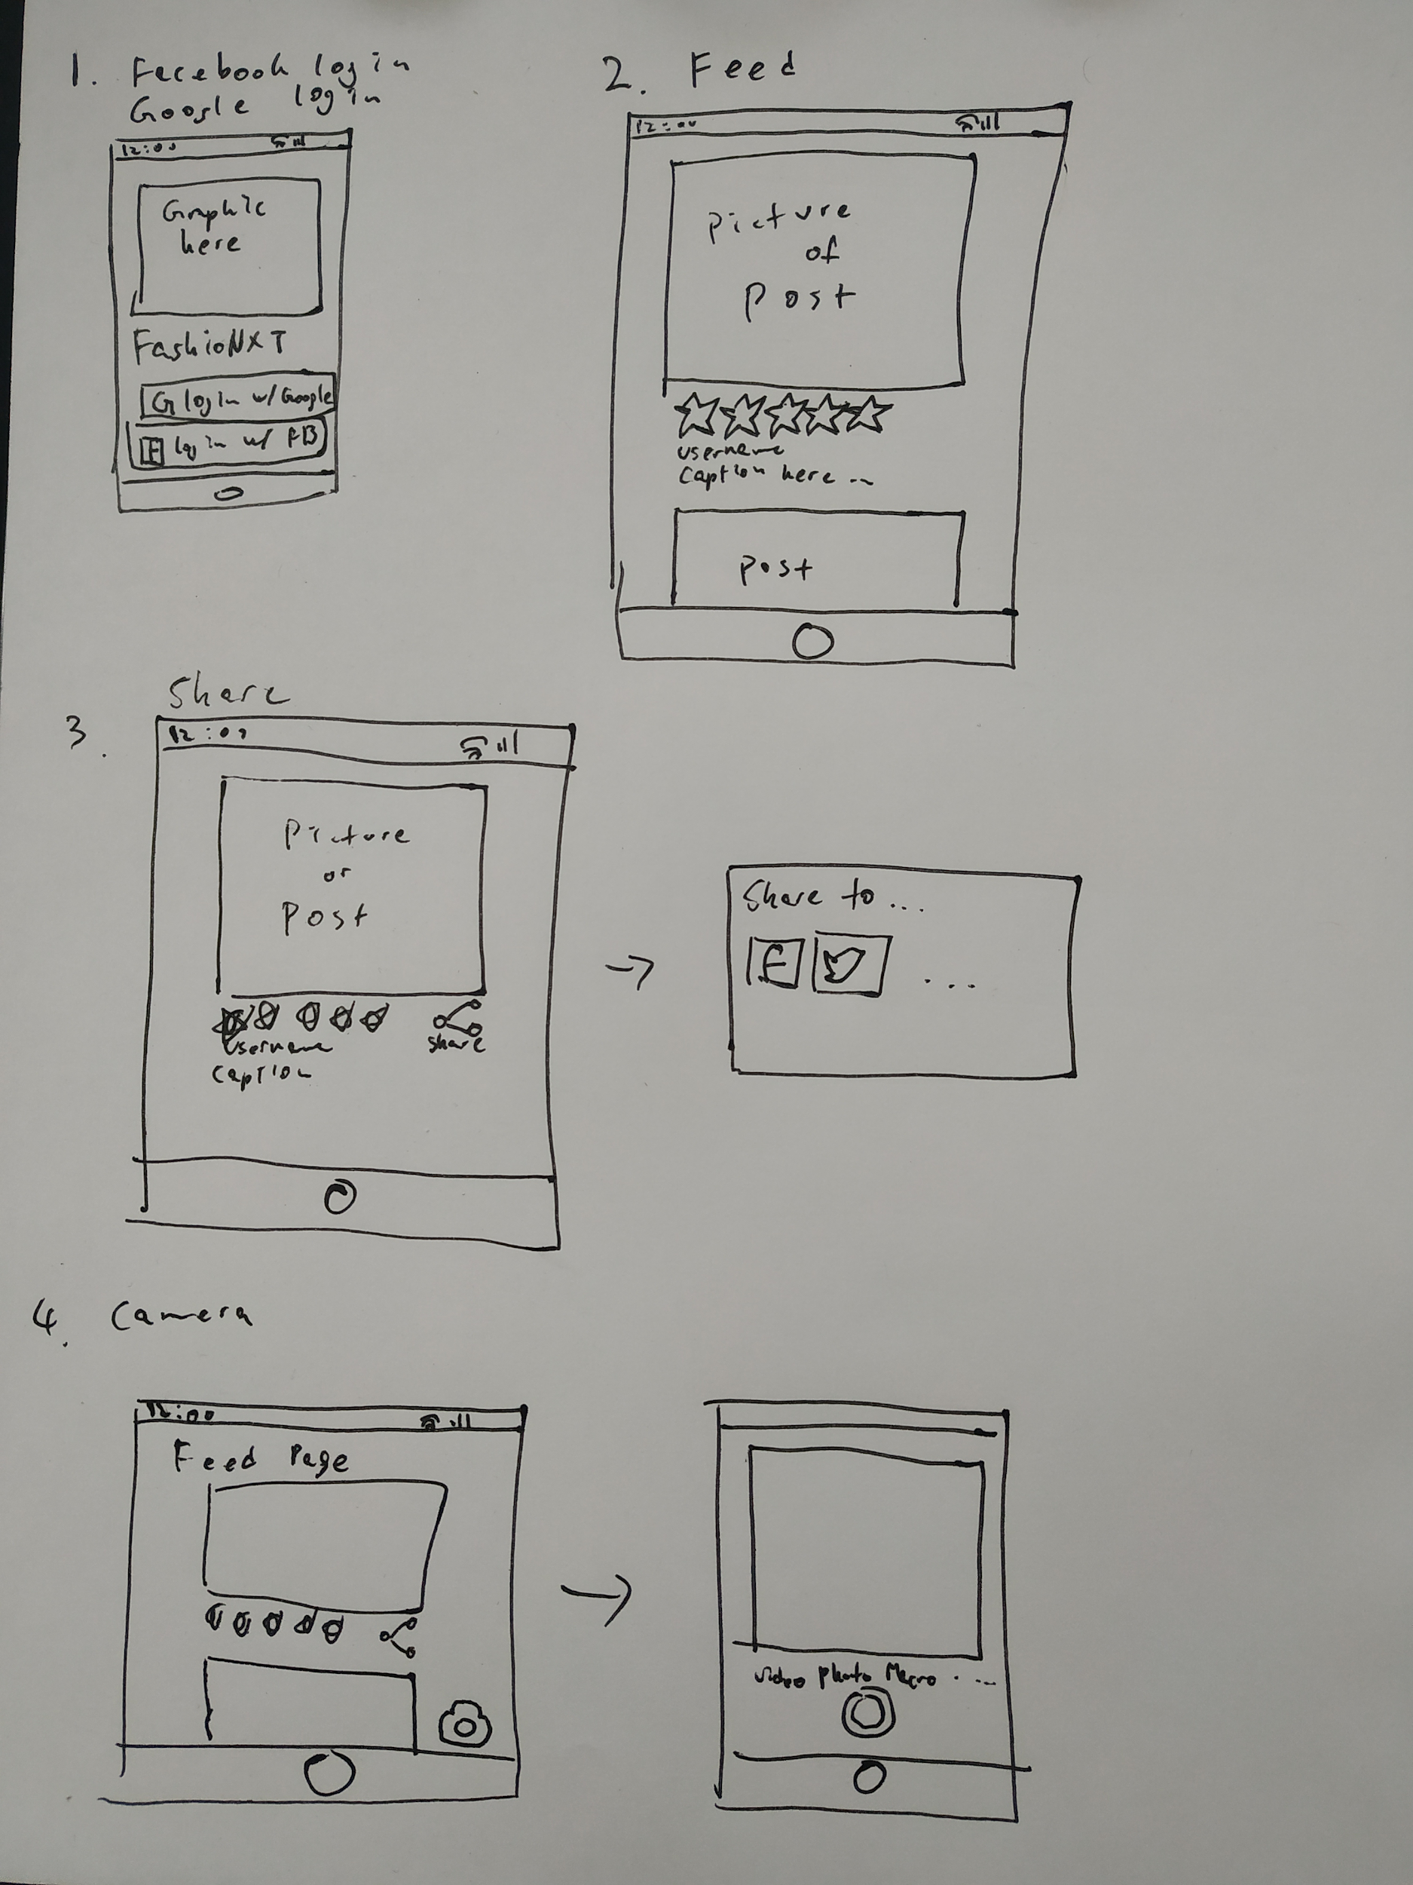

Pivotal Tracker

* <https://www.pivotaltracker.com/n/projects/2467831>

Github

* <https://github.com/FashioNXT/WooLaLa2020>